- Write a SQL statement that will list the first and last names of any customer who has ordered a Fender Stratocaster guitar.
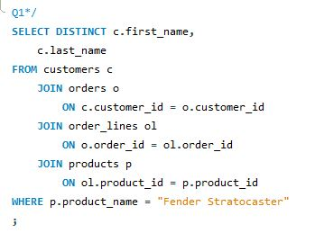

- Write the plain English for the following SQL statement.
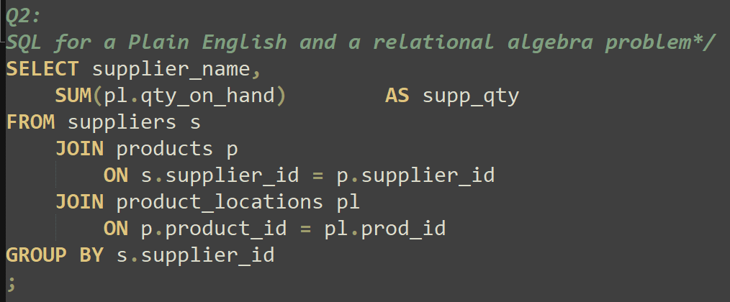

List the supplier’s name and the total quantity on hand for each supplier.

- Write the relational algebra expressions for the SQL statement in the preceding question. Add rows to the table as necessary.
SUPPLIERS(*)  PRODUCTS(*) | SUPPPROD ⟵SUPPLIERS ⨝ _{supplier_id = supplier_id} PRODUCTS
SUPPLIERS(*)  PRODUCTS(*)  PRODUCT_LOCATIONS(*) | SUPPPRODLOC ⟵SUPPROD ⨝ _{product_id = prod_id} PRODUCT_LOCATIONS
SUPPLIERS(*)  PRODUCTS(*)  PRODUCT_LOCATIONS(*) | RESULT1⟵ ρ_{(supplier_name, supp_qty)}(_{supp_qty} ℑ _{SUM(qty_on_hand)} (SUPPRODLOC))
SUPPLIERS(supplier_name)  PRODUCT_LOCATIONS(qty_on_hand) | RESULT ⟵π _{(supplier_name, supp_qty)}(RESULT1)

- Write a SQL statement that lists each warehouse name and the total of the list prices for all products in inventory at the warehouse.
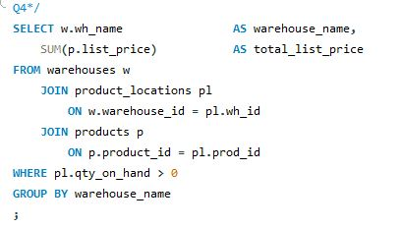

- For the three customers with the most orders, list their first name, last name, and the number of orders they have placed. Use appropriate column names.
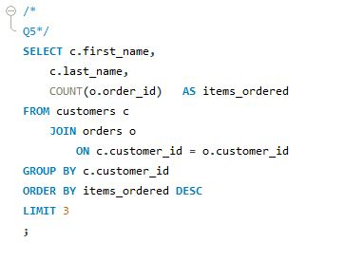

- Write a SQL statement that will list the names of products that have never been ordered. Do not use an outer join to solve this problem.
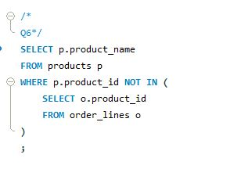

- Write a SQL statement that will list the name of any supplier who has supplied a least one product in the Basses category and one product in the Guitars category. You may not use an outer join in your statement. You must use the INTERSECT keyword in your answer.

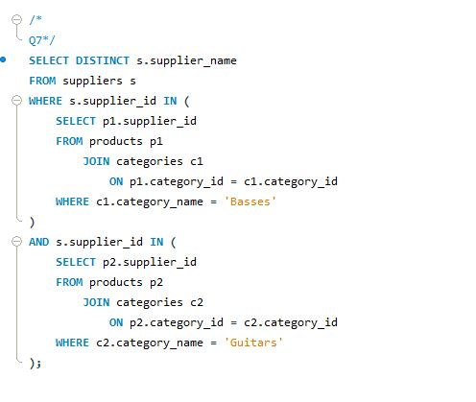
(mySQL does not support INTERSECT keyword)

